Title in English (Times New Roman; size-13; Interline 1,15)
العـنـوان باللغة العربية (الخط: Traditional Arabic، حجم الخط 15، تباعد أسطر 1,15)
Full name of the first author , Full name of the second author

Abstract: (Do not exceed 150 words)
Enter your abstract here (an abstract is a brief, comprehensive summary of the contents of the article). Enter your abstract here (an abstract is a brief, comprehensive summary of the contents of the article). Enter your abstract here (an abstract is a brief, comprehensive summary of the contents of the article).
Enter your abstract here (an abstract is a brief, comprehensive summary of the contents of the article).
Keywords: keywords; keywords; keywords; keywords; keywords.
JEL Classification Codes: …, …, …

ملخص: ) 150 كلمة على الأكثر)
ضع الملخص هنا (يتم الإشارة في الملخص إلى هدف البحث، والنتائج المتوصل إليها في فقرتين). ضع الملخص هنا (يتم الإشارة في الملخص إلى هدف البحث، والنتائج المتوصل إليها في فقرتين). ضع الملخص هنا (يتم الإشارة في الملخص إلى هدف البحث، والنتائج المتوصل إليها في فقرتين). ضع الملخص هنا (يتم الإشارة في الملخص إلى هدف البحث، والنتائج المتوصل إليها في فقرتين). ضع الملخص هنا (يتم
كلمات مفتاحية: ك. م.، ك. م.، ك. م.، ك. م.، ك. م.
تصنيفات JEL : ....، ....، ....

_____________

1. INTRODUCTION
The first subtitle opens with an introduction that presents the specific problem under study and describes the research strategy. The first subtitle opens with an introduction that presents the specific problem under study and describes the research strategy. (Times New Roman13, interline 1.15)

2. Title
2.1 First Subtitle
Enter here the text of first subtitle, Enter here the text of first subtitle, Enter here the text of first subtitle, Enter here the text of first subtitle, Enter here the text of first subtitle, Enter here the text of first subtitle, Enter here the text of first subtitle.
2.2 Second Subtitle
Enter here the text of second subtitle, enter here the text of second subtitle, enter here the text of second subtitle, enter here the text of second subtitle, enter here the text of second subtitle, enter here the text of second subtitle, enter here the text of second subtitle.

3. Title
3.1 First Subtitle
Enter here the text of first subtitle, Enter here the text of first subtitle, Enter here the text of first subtitle, Enter here the text of first subtitle, Enter here the text of first subtitle, Enter here the text of first subtitle, Enter here the text of first subtitle.
3.2 Second Subtitle
Enter here the text of second subtitle, enter here the text of second subtitle, enter here the text of second subtitle, enter here the text of second subtitle, enter here the text of second subtitle, enter here the text of second subtitle, enter here the text of second subtitle, enter here the text of second subtitle, enter here the text of second subtitle.

Table 1. Table title (this is an example of table 1)
Test 1 | Test 2 | Results 1 | Results 2 | Total Results
15.21 | 15.21 | 15.21 | 15.21 | 15.21
18.58 | 18.58 | 18.58 | 18.58 | 18.58
11.14 | 11.14 | 11.14 | 11.14 | 11.14
Source: author’s name, year, page
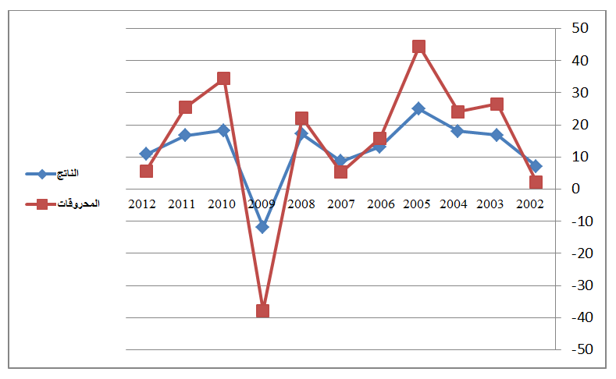
Fig.1. Figure title (this is an example of figure 1)

Source: author’s name, year, page

4. CONCLUSION
The conclusion of a research paper needs to summarize the content and purpose of the article. The conclusion of a research paper needs to summarize the content and purpose of the article. The conclusion of a research paper needs to summarize the content and purpose of the article. The conclusion of a research paper needs to summarize the content and purpose of the article. The conclusion of a research paper needs to summarize the content and purpose of the article. The conclusion of a research paper needs to summarize the content and purpose of the article.

5. Bibliography List :
Use the « APA Reference System », see the link :
The references must be directly quoted in the body of the text (eg: ... (Brown, 2006, p35), without omitting to mention the complete reference in the list of references at the end of the document, written in the following manner:
- Books : author’s name (year), full title, publishing, country;
- Theses: researcher (year), thesis title, college, university, country ;
- Journal article : author’s name (year), full title of the article, review name, place, volume and number, page ;
- Seminar article: author’s name (year), full title of the paper, title of seminar, place and date, country ;
- Internet websites: author’s name (year), full title of the file, detailed web site : http://fulladdress (consulted on day/month/year).

6. Appendices

